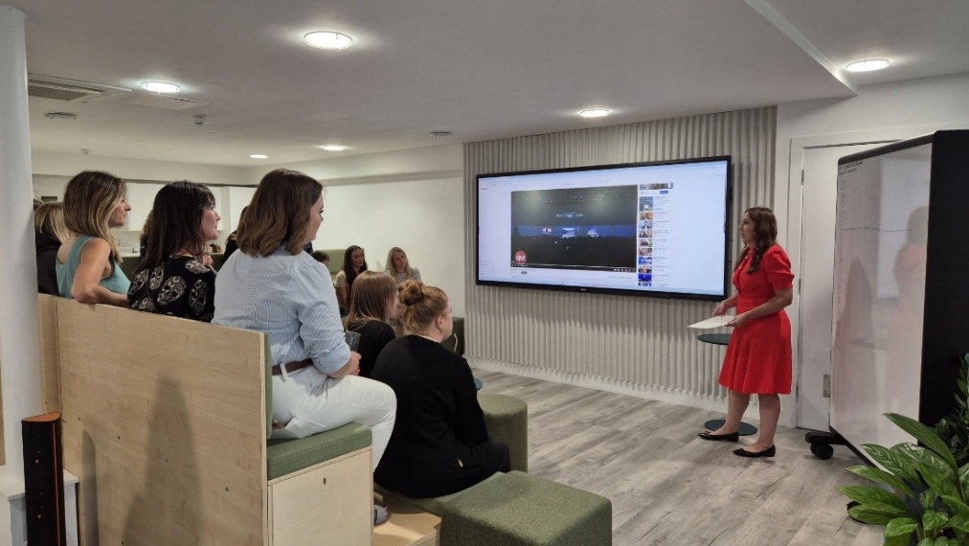

Sennheiser partners with Rise AV to support diversity in the AV industry

Sparking creativity and innovation with gender diversity

Wedemark, August 29, 2025 – The Sennheiser Group is proud to join forces with Rise AV, a non-profit organization dedicated to advancing gender diversity and inclusion in the audiovisual (AV) sector. As a Gold Sponsor, Sennheiser supports Rise AV’s mission to create pathways for women and underrepresented talent. By supporting Rise AV, Sennheiser contributes to a shared vision: an AV industry where talent is recognized regardless of gender, and where inclusive structures enable long-term change.

“Through our partnership with Rise AV, we aim to help amplify and empower more voices to shape the future of the audio world. Because when people from diverse backgrounds come together, creativity and innovation emerge in unexpected ways,” says Mareike Oer, Head of Brand & Corporate Communications at the Sennheiser Group. The sponsorship includes support for Rise AV’s flagship Mentoring Programme and the Elevate leadership initiative, alongside opportunities for workshops, training sessions, and internships. These activities create direct touchpoints for dialogue, learning, and exchange - strengthening inclusive structures within the AV industry and complementing Sennheiser’s internal DEI engagement. The partnership with Rise AV is part of a continuous journey: fostering more inclusive, open, and inspiring environments across the whole AV industry.

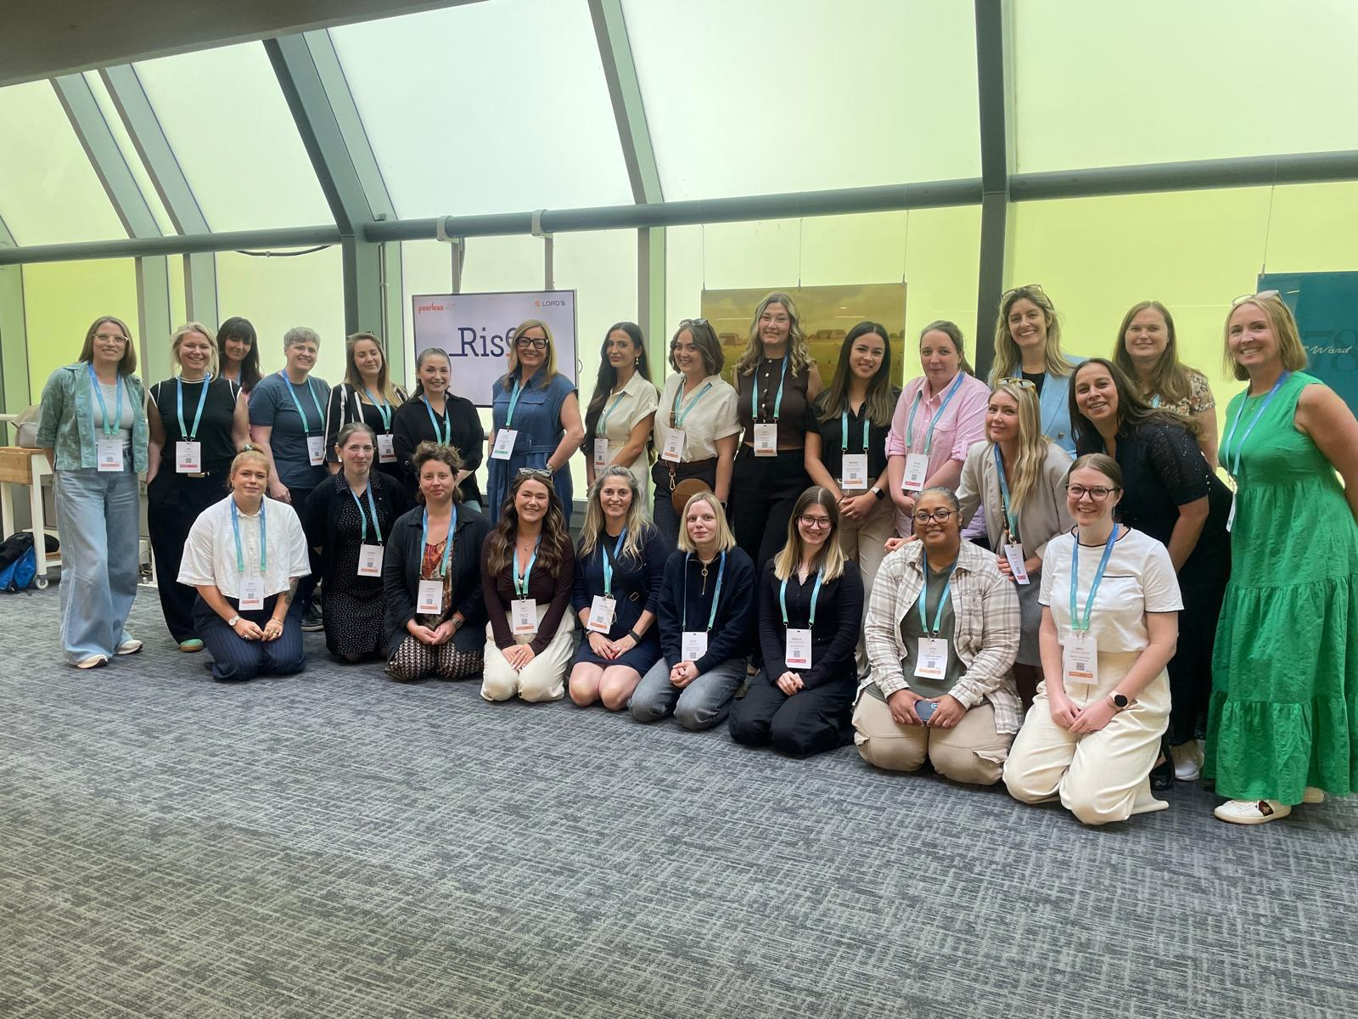
The first group of Rise AV mentees at the program launch.
Sennheiser has been advancing diversity, equity, and inclusion through initiatives such as its Diversity Network, launched in 2019 and rooted in a women’s network from 2016. Other milestones include the signing of the German Diversity Charter in 2022, the introduction of global DEI training for all employees by 2025, and the annual celebration of Diversity Day. Together, these measures reflect a culture where every voice counts, and different perspectives are valued as sources of innovation. “At Sennheiser, diversity is not an add-on - it’s part of who we are,” says Daniel Sennheiser, Co-CEO of the Sennheiser Group. “Innovation and creativity flourish when different perspectives come together. Our team is a vibrant mix of people from many cultures and life paths - just like our customers all over the world. Supporting Rise AV means amplifying that richness across the AV industry.”
About the Sennheiser Group
We live and breathe audio. We are driven by the passion to create audio solutions that make a difference. In 2025, the Sennheiser Group celebrates its 80th anniversary. Since 1945, we stand for building the future of audio and bringing remarkable sound experiences to our customers. Today, the Sennheiser Group is one of the leading manufacturers in the field of professional audio technology. With our brands Sennheiser, Neumann, AMBEO and Merging, we offer a comprehensive range of solutions that is fully tailored to the needs of our customers. As independent family-owned company Sennheiser is led in the third generation by Co-CEOs Dr. Andreas Sennheiser and Daniel Sennheiser. www.sennheiser.com

Press contact
Sennheiser electronic SE & Co. KG
Mareike Oer
Brand & Corporate Communication
T +49 (0)5130 600-1719
mareike.oer@sennheiser.com

